Search & Discovery

Simplification of Adding a Store
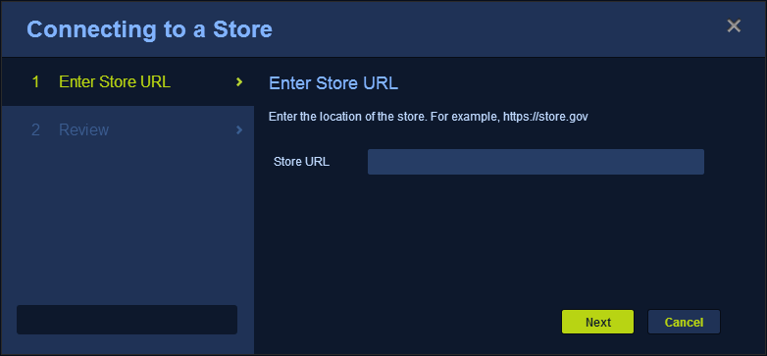
Figure 1: Store Wizard in OWF
- Added a Store Wizard for adding Marketplace associations with OWF.
- Users can add listings from Affiliated Stores directly to OWF pending that an OWF Administrator has added the Affiliated Store as an app component.
- Combine drop-down User Menus to allow users to see their Store and OWF user’s options as one list if the products are used together.
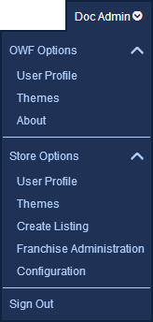
Figure 2: Combine drop-down User Menu

Create/Edit Form Changes
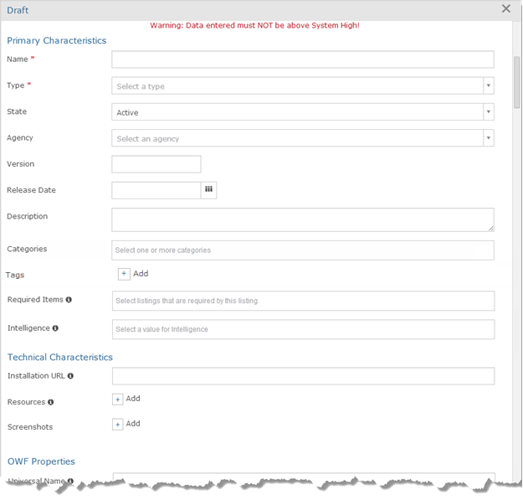
Figure 3: Top of the Modal Create/Edit Form
- Create/Edit form
  - Provided ability to add agency association and required listings directly from the Create/Edit form.
  - Create/Edit form became a modal window that is consistent with the updated UI.
  - Renamed Documentation to Resources on the Create/Edit Listing form.
  - Owners/administrators can add more than one resource, owner and screenshot to a listing.
  - Added contacts to the form, then improved it to allow for the addition of multiple custom contact types.

Filters Improved on the Discovery and Search Pages

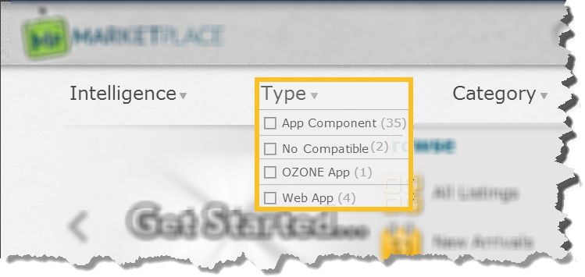
Figure 4: Filters Appear on Hover
- Filters appear when hovering over them in the Store.
  - Added default categories as well as allowing for modifications to all categories.

Listing Quick View
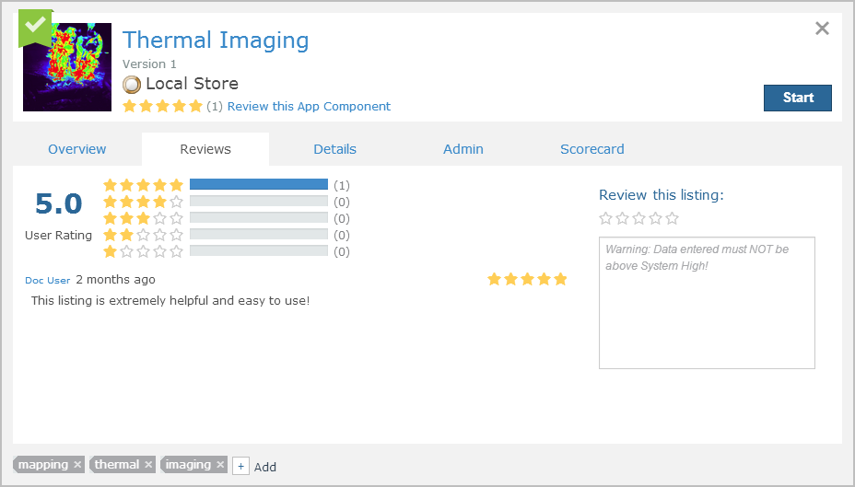
Figure 5: Listing Quick View
- Listing Quick View switched to a modal window.
  - Spacing, colors and the closing “X” were standardized to improve the appearance of the Quick Listing View.
  - On the Details tab, the approval status now appears as “Approval/State.” This format was inconsistent in the past. It now provides users information about the status and the state of the listing.
  - Added screenshots to the Quick Listing View and the ability to enlarge the screenshots outside the Quick View window.
  - Made Required and Required By listings in the Quick View active links.
  - Listing Details Page removed after the Quick View deprecated its function.
  - Add ability to traverse related listings and users in a single window using back-links.

Tags
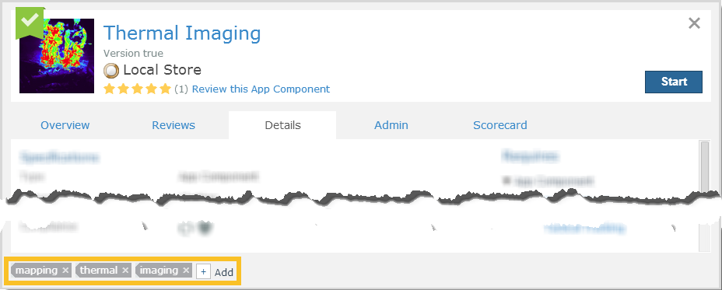
Figure 6: Tags
- Store users can now add tags to listings. This feature will aid in Search and Discovery by enabling organic grouping of listings through user-generated labels.
  - Added the following options: browse by Tags, Display tags by User on the Profile Window, display All Tags as a list or tag cloud:
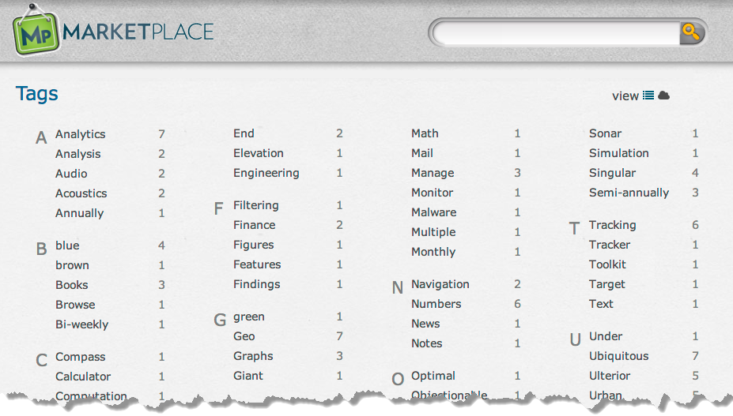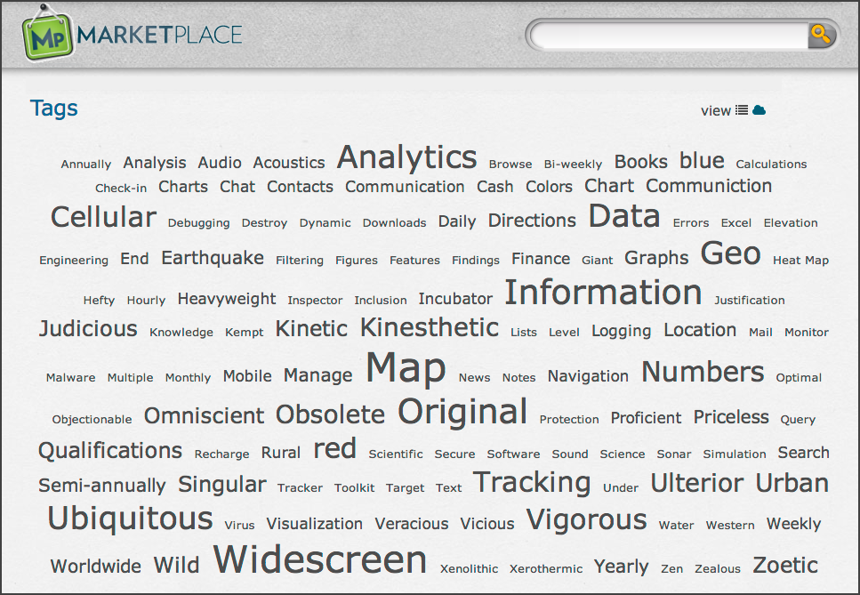
Figure 7: Tags Consoles shown as a List and Tag Cloud

Affiliated Marketplaces
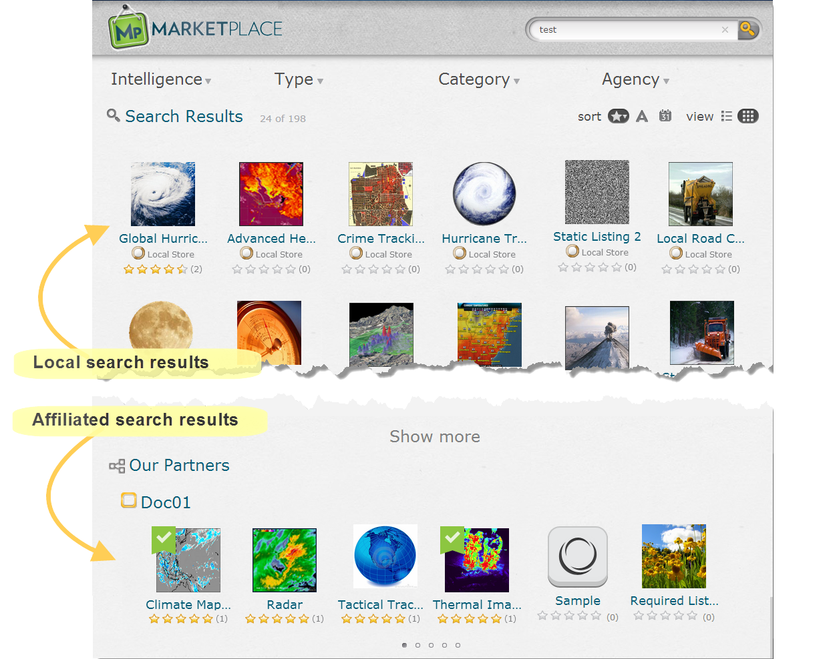
Figure 8: Search Results including those from an Affiliated Store
- Listings from Affiliated Stores now share the same look and feel as listings from the local store.
Note: The appearance and function of Affiliated Stores is limited by the version of the Store. For example, if you connect to a store that predates an improvement, that improvement will not appear in that Store or its listings.

Content Management

Product Interaction
- Animations added to the Store signifying that an app component was added from the Store to OWF.
  - Added the ability for users to turn animations on/off for their instance of OWF and the Store.
- Favorites Flag added to listings on the Discovery Page, Search Results and Quick Listing Form in Stores to identify that the listings have already been added to OWF.
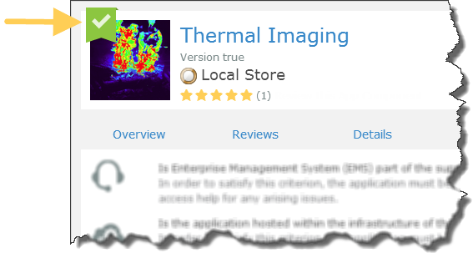
Figure 9: Favorites Flag

Applications (formerly Stacks)
Definition: A user-defined template where application components are added, arranged and used. Applications have customizable layouts that organize application components and improve users’ workflows.
- Introduction of Applications (called Stacks at the time of implementation). This provided a means to group applications.
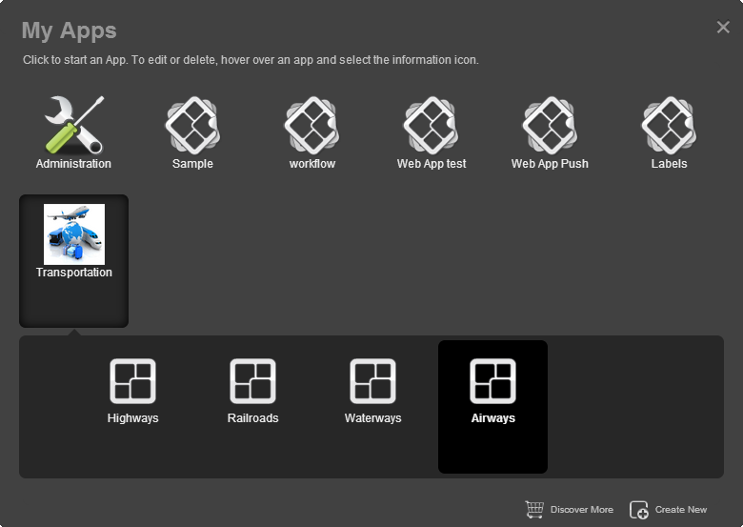
Figure 10: The My Apps Window in OWF
- In OWF instances that run independent of the Store, users can share their applications.
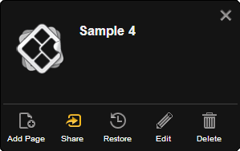
Figure 11: Ability to Share Apps in an OWF that is not associated with a Store
- Start OWF-aware Apps from the Store (in previous releases this ability was reserved for Web Apps and App Components).
  - Allow owner/admin to decide if the listing launch URL is OZONE Compatible.
  - Added the “Opens in a new browser tab” button that allows owner/admin to decide if the listing launches inside OWF or in its own browser tab.
- Add an Application from the Store to OWF.
  - New functionality in the My Apps Menu allows users to add a page to the application and push it to the Store.
  - Import Applications from OWF into the Store.

App Components
Definition: A lightweight, single-purpose Web application that offers a summary or limited view of a larger Web application. Formally referred to as a widget, an app component is a global description for a piece of Web content that can be configured by the user and displayed within an application.
- Intents are now sent to OWF via synchronization.
- Redesigned and simplified Launch Menu for App Components (formerly called Widgets).
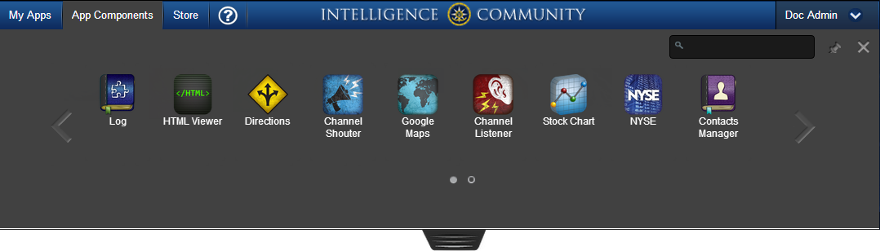
Figure 12: App Component Menu

Web Apps
Definition: A program that cannot interact with other App Components. Web Apps automatically open as their own OZONE App or in a new browser tab.
- Allow users to launch a Web App from the Store.
  - Users can start a Web App from the Quick View:
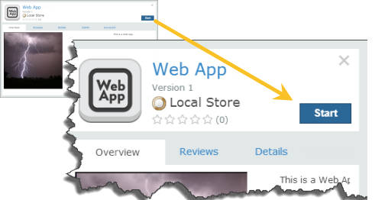
Figure 13: Web App in the Store

User Activity
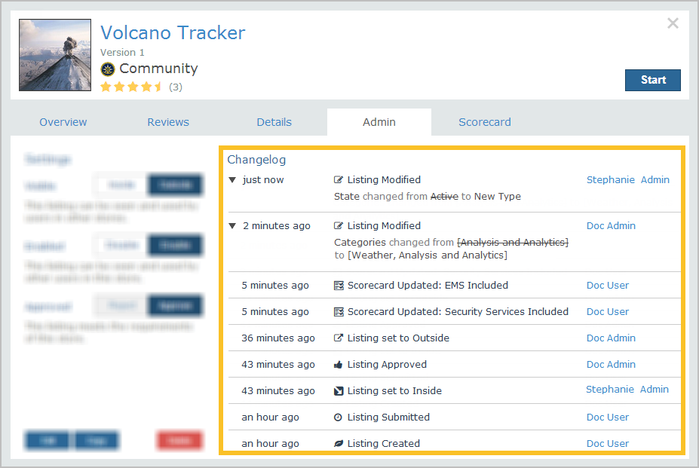
Figure 14: Changelog improvements
- The following improvements occurred in the Changelog:
  - Corrected reporting and sorting.
  - Included an accurate timestamps.
  - Recorded custom fields.
  - Listing modification entries display correct details for custom fields, complex objects and multi-value fields like Technical POCs, Doc URLs, etc.
  - If a user clicks edit but does not change a listing, the Changelog does not log a change.
  - Updates to the Resource field display the correct data.
  - Tech POC entries no longer remove references to old tech POCs when a new one is added.
  - Rejected listings now have old and new values.
  - Scorecard details display in the Changelog.
  - Recommended layouts and intents no longer log changes that have not happened.
  - Owners, release dates, states and categories record events correctly.
  - Add administrative and tag changes are included in the changelog.

Profile Window
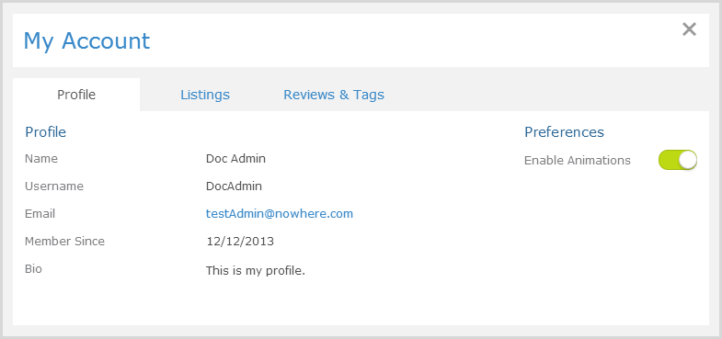
Figure 15: Updated Profile Window
- Store Profile Page replaced with a Store Profile Window that matches the consistency of the rest of the UI.
- My Listings page removed and information moved to the Listings and Reviews & Tags tabs of the My Profile window.

Administrative Functions
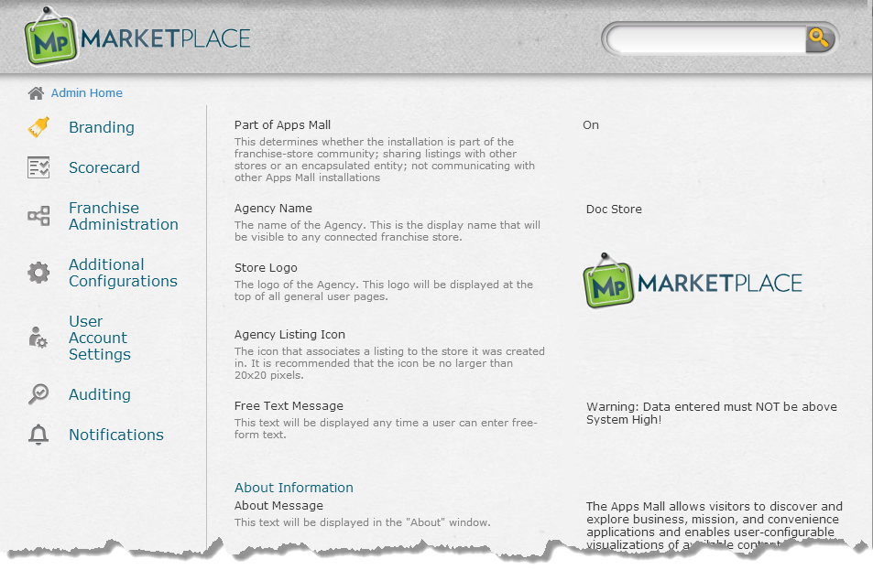
Figure 16: Store Administrative Console
- Moved configurations to the UI, eliminating the need for server reboots after many changes.
- Updated the application configuration interface, specifically moved configurations for store logo, icons, external service item, etc. to the UI.
  - Updated the Listing Management Page to feature Pending Listings and automatically display the last 24 listing changes (this list can be expanded).
  - Added Contacts to Listings and then provided admins with the ability to create custom contact types in the Contacts field on ServiceItems.
  - Administrators can create or delete any tag from the system.

Administrative Functions Moved to the Quick View
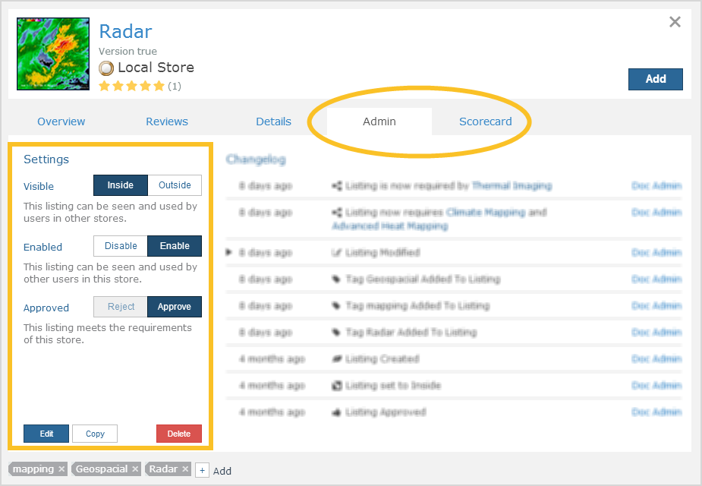
Figure 17: Administrative Functions moved to the Quick View
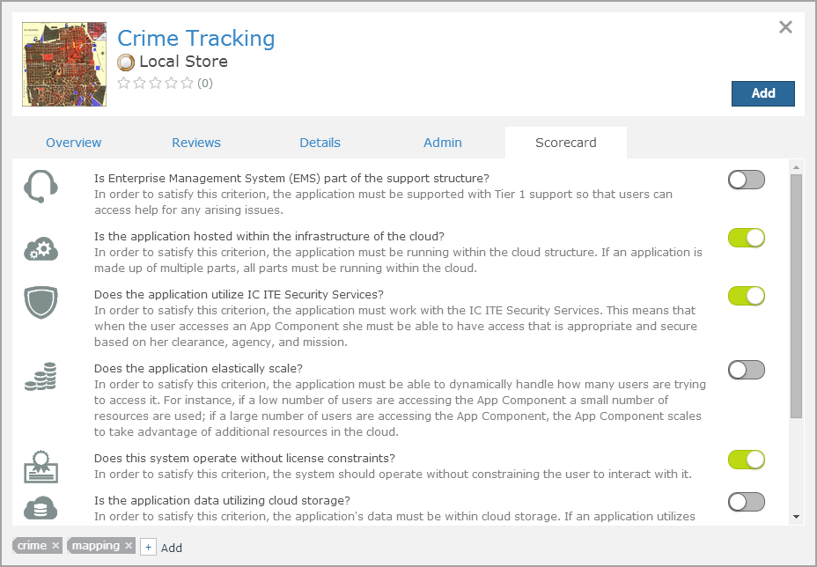
Figure 18: Scorecard Tab on the Quick View
- Moved listing administrative functions from the Detailed Listing Page to the Admin tab of the Listing Quick View, this includes the listing Visibility, Enabled/Disabled Status, Approval, Edit and Delete functions. Then, continued enhancement of Quick View by adding a Scorecard tab where administrators can score listing compliance. Also, included more Specifications on the Details tab and allowed administrators to edit and delete comments on the Reviews tab of the Listing Quick View.

Data Exchange
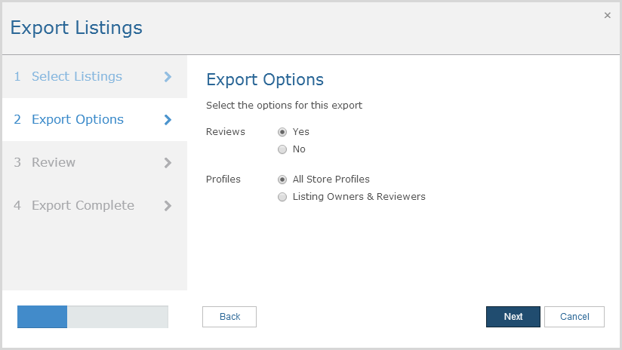
Figure 19: Export Wizard
- Enhanced import/export to allow for individual import/export of listings as well as omission or inclusion of specific listing types, categories, ratings/comments, agency affiliation, system-wide user profiles and inside/outside status.

Build an App
Definition of the App Builder: A tool in OWF where users can create or edit their own customized Applications.
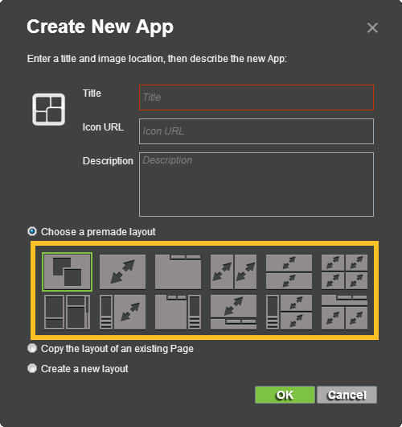
Figure 20: App Builder Templates
- Templates added to the App Builder.
- The App Builder now includes labels:
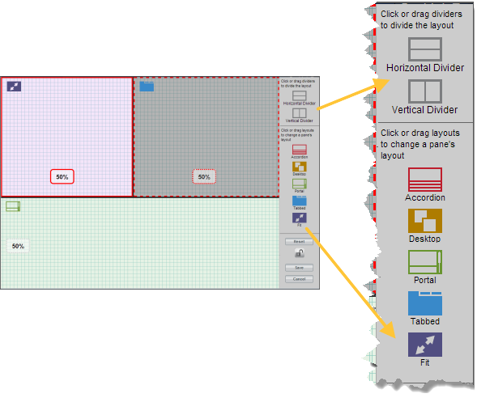
Figure 21: Labels on the App Builder
- Ability to start an App Component in a new pane using a Widget API
- Start Listing Workflow Improved through subtle cues that guide users through the start process when opening a listing into OWF from the Store:
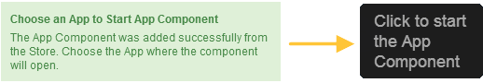
Figure 22: Examples of cues that guide users as they add listings from Marketplace to OWF

Misc

REST APIs
- Created new REST APIs, using Agency as the first object to use it.
- REST APIs will return the app version in a new REST call in OWF. This feature will help developers identify the compatibility and availability of features.
- Improved the ability to manipulate ServiceItems from a REST API (create, read, edit, delete, submit, reject, authorize).
- Specific new APIs:
  - Agency
    - (root resource) - provides basic information about the Store
    - (version, name, build number, build date)
  - Contact Types - done in the new API, however, follows old-style
    - Controllers were also added to make building admin pages easier
  - Profile
    - Supports GET, and PUT (update bio)
    - Does not support Create (that is handled by the security plugin)
    - Does not currently support updating of preferences (animations, theme). However, this may be added once user domain objects are cleaned up.
    - retrieve user's listings
    - retrieve user's comments
    - retrieve user's tags
    - retrieve user's changelogs
    - retrieve combined changelogs of user's listings
  - SPA page Search - implemented in new REST API
  - ServiceItem REST - Started in early December; merged into master in late December
    - Started with basic CRUD operations, plus Submit and approve, over time additional capabilities were added
    - retrieve changelog for ServiceItem
    - retrieve global changelog
    - rejection
    - retrieve required and requiring listings
    - CRUD on comments/reviews
  - Tags
    - Basic Tag CRUD
    - Retrieve by title
    - Retrieve by listing

Security/Database Improvements
- Audit events (CEF Logging) added to event logs in both products.
- Addressed widget descriptor export issues with the default server that would have allowed for HTML Injection and XSS scripting in description field.
- Fixed a cross-domain issues that caused eventing to break in Chrome 30.

General Misc.
- Release Date no longer associated with a time zone.
- Nomenclature was modified to synchronize with standard mobile device terminology, i.e. application, app component, etc.
- Converted JSDocs to MarkDown.
- Listing Review prompt added to remind users to review a listing.
- Addressed group dashboard capacity that caused Oracle errors when more than 1,000 users had their own copy of a Group Dashboard.
- Added cross-origin resource sharing (CORS) support for OWF and Marketplace. This allows the products to support newer browsers (IE10+, etc.) and query/use modern technology (HTML5, etc.).
- Marketplace includes a Tutorials page. Accessible from the footer, the Tutorial page houses an OZONE Overview video and training slides.

